# Tutorial – Talend – SCD Type 2 - Example 1

## Objective:

Demonstrate SCD using Employee Department History as the example

## Source & Targets: (located in NEU SharePoint folder)

Source: csv file - EmployeeDeptHistory.csv

Target: MySQL table - EmployeeDeptHistory_scd

SQL script: create_table_EmployeeDeptHistory_scd_mysql_tutorial.txt

## Tasks:

1. Download source file & target SQL script from NEU SharePoint folder
2. Create MySQL table
3. Open Talend
4. Add/retrieve schema for MySQL database
5. Add File delimited connection
6. Create SCD job (see below) & video

Run Talend, select workspace you want to work in

## Talend Example

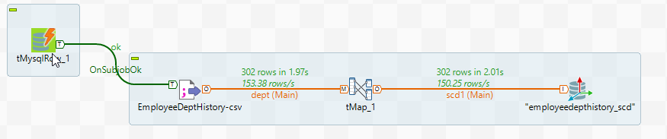

## Results

SELECT 'SCD Inactive', count(*) FROM neu_training.employeedepthistory_scd where scd_active = 0

union

SELECT 'SCD Active', count(*) FROM neu_training.employeedepthistory_scd where scd_active = 1

|  |  |
| --- | --- |
| **SCD Inactive** | **count(*)** |
| SCD Inactive | 12 |
| SCD Active | 290 |

SELECT *

FROM neu_training.employeedepthistory_scd

where scd_active = 0

;



SELECT *

FROM neu_training.employeedepthistory_scd

where scd_active = 1 limit 10

;

